Three famous writers
William Shakespeare (1564-1616) is English playwright and poet, recognized in much of the world as the greatest of all dramatists. Shakespeare wrote nearly all of his plays from 1590 to 1611.The great tragedies - including Hamlet, Othello, King Lear, and Macbeth - were written during the first decade of the 1600s. Shakespeare died on April 23,1616. Shakespeare’s reputation as dramatist, poet, and actor is unique... Sadly his life-story remains ill-documented. We know that Shakespeare was born in Stratford-upon-Avon in Warwickshire, England, and that he was probably educated in the town’s free grammar school. Then in 1582 he married Anne Hathaway. The first collected edition of Shakespeare’s works was published after his death in 1623 and is known as the First Folio. The plays fall into the categories o f history, tragedy, comedy, and tragicomedy.

Agatha Christie (1890-1976) is a British author of mystery novels and short stories, especially famous as the creator of Hercule Poirot, the Belgian detective, and Miss Jane Marple. Agatha Christie was born in Torquay, in the county o f Devon. Christie was educated at home, where her mother encouraged her to write from a very early age. In 56 years, Christie wrote 66 detective novels, among the best of which are The Murder of Roger Acroyd, Murder On The Orient Express (1934), Death On The Nile (1937). In 1967, she became president of the British Detection Club, and in 1971, she was made a Dame of the British Empire. Christie died on January 12,1976. With over one hundred novels and 103translations into foreign languages, Christie was by the time of her death the best-selling English novelist of all time. Agatha Christie (1890-1976), English novelist, who was a prolific writer of mystery stories. She was born in Torquay. In 1930, while travelling in the Middle East, Christie met the noted English archaeologist Sir Max Mallowan. They were married that year, and from that time on Christie accompanied her husband on annual trips to Iraq and Syria. In 1971 she was made a Dame Commander of the Order of the British Empire.

Ahmed Shawqi (1868-1932) is Egyptian poet and dramatist. He produced distinctive poetry that is widely considered to be the most prominent of the 20th century in Arabic literary movement. His family was well-connected with the court of the Khedive of Egypt. He attended law school, obtaining a degree in translation. He was then offered a job in the court of the Khedive Abbas II, which he immediately accepted. After a year working in the court of the Khedive, Shawqi was sent to continue his studies in Law at the Universities of Montpellier and Paris for three years. Shawqi was the first in Arabic literature to write poetic plays. He wrote five tragedies and two comedies. Al Shawqiyat includes Nahj al-Burda, a tribute to the prophet Muhammed. He is known as ‘the poet of Arabism and Islam’. Al Shawkiyat remains a classic of Islamic literature. After completing his education in law in Paris in 1893 and spending an additional six months in France, he returned to Egypt. Celebrating the publishing of the second edition of Al Shawkiyat, in April 1927, he was named Poet Laureate of Egypt.

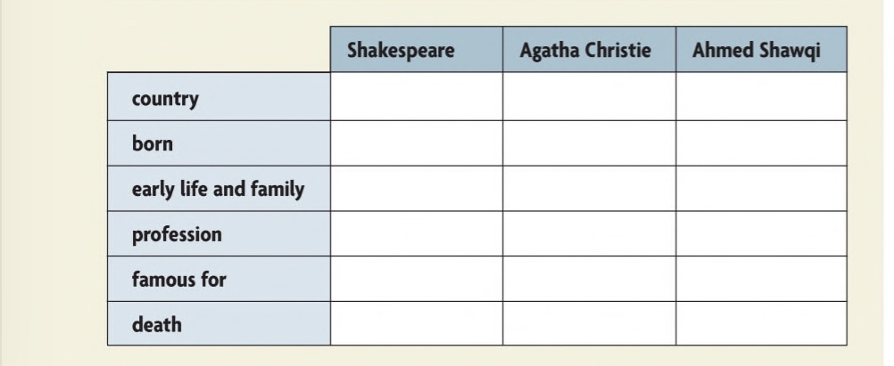
Scan the extracts above and complete the notes in the chart.

